**Introduction to Linked List**

1. **Pointers?**

**Int v = 25;**

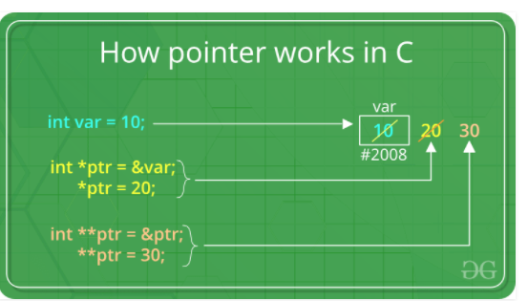

**OUTPUT Questions :**

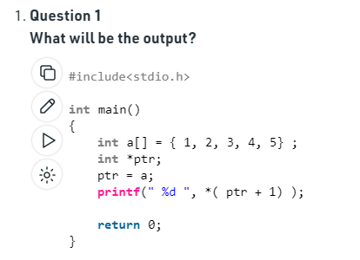

1. **Structures in C++?**
2. **What is Linked List?**

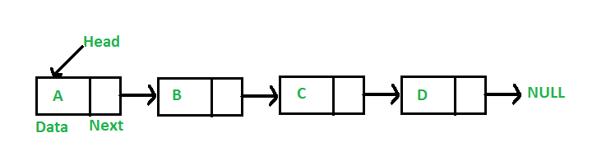

1. **Why Linked List?**
2. **Types of Linked List?**
3. **Questions on Linked List?**